Sensitivity of Biogenic Emissions to Climate

Jihee Song
Global Physical Climatology, GEO 387H
December 5, 2006

Abstract: Trees provide a major source of reactive hydrocarbon into the atmosphere. These BVOCs react with nitrogen oxides emitted from anthropogenic sources, such as combustion sources, and, to a lesser extent, from soils in the presence of sun light to produce ground level ozone and other manifestations of photochemical air pollution which can cause health problems and detrimental effects on plants and ecosystems. Due to the significance of BVOCs, especially isoprene, the sensitivity of emission to climatic factors has been investigated for a long time. However, uncertainties in the effects of climatic factors, e.g., light intensity, relative humidity, CO₂ concentration, due to the limited number of species and conditions for which emission measurements have been made are still remaining. Results of this review demonstrate that isoprene emissions are strongly linked to climate variables which have changed in the past and have great potential to change further in the future. Also, results have demonstrated that this link between isoprene emissions and climate variables should be considered with vegetation species. Since isoprene and other biogenic VOC play a large role in producing ground level ozone, a better understanding of the potential changes in biogenic emissions from natural global change, as well as human-induced change, is needed.

1. Introduction
The terrestrial vegetation is a major source of biogenic volatile organic compounds (BVOCs) into the atmosphere. Guenther et al. (1995) has estimated that the annual global emission of BVOCs is approximately 1150 Tg C (1 Tg = 10¹² g), which is an amount larger than emissions from all anthropogenic VOC sources. Global BVOC emission models estimate that 43% of total BVOC inventory are isoprene (C₅H₈), which is a highly reactive hydrocarbon (Figure 1; Guenther et al., 1995). Important sources of isoprene are deciduous trees such as poplar and oak.

Figure 1. Global natural VOC emission rate estimates in percentage. Natural VOC are classified into four categories: isoprene (C₅H₈), monoterpene (C₁₀H_{x}), ORVOC (other reactive VOC, C_{x}H_{y}O_{z}), and OVOC (other VOC, C_{x}H_{y}O_{z}). From Guenther et al. (1995).

BVOCs react with nitrogen oxides emitted from anthropogenic sources, such as combustion sources, and, to a lesser extent, from soils in the presence of sun light to produce ground level ozone and other manifestations of photochemical air pollution (National Research Council, 1991). Ground level ozone can cause health problems such as lung malfunctioning and the irritation of respiratory system, as well as detrimental effects on plants and ecosystems (EPA; Available at http://www.epa.gov/air/urbanair/ozone/hlth.html). Due to the significance of BVOCs, especially isoprene, the sensitivity of emission to climatic factors has been studied for a long time. Although there are considerable uncertainties in these relationships between climatic factors and biogenic, isoprene, emissions, at the present time most of studies focus on the biogenic emission modeling using these relationships. Further more, these biogenic emission estimates are used to predict global / regional air quality. The purpose of this paper is to provide an up-to-date review of the rapidly expanding body of information regarding the biogenic emissions and to highlight areas of current uncertainty.

2. Review of Previous Works
BVOC emissions from ecosystems are dependent on land cover (plant species composition and density) and are sensitive to a number of climatic factors, the most important of which are light, and surface temperature, but which include time of day, season, absolute / relative humidity, CO₂ concentration, and other stresses (Fuentes et al., 2000; Guenther et al., 1999; Kesselmeier et al., 2002; Lerdau et al., 1997). Although parameters are very closely linked each other, I will review the principal climatic controls dictating the emissions of biogenic volatile organic compounds. Most of the papers that are reviewed here are both based on the field study and the chamber study, and I tried to exclude the results from models.
There are several studies which showed that biogenic emission rates vary as a function of climatic factors.

Temperature and PAR
Isoprene emissions are controlled by both surface temperature and light over short time periods (Guenther et al., 1993). Figure 2 shows the variation of the emission rate of isoprene as a function of leaf temperature. Isoprene emissions respond strongly to temperature, increasing rapidly between 15 and 35ºC (Fehsenfeld et al., 1992; Feuntes et al., 2000; Guenther et al., 2000, 1999, 1993, 1991; Lerdau et al., 1997; Monson et al., 1994; Monson and Fall, 1989; Sharkey et al., 1991; Tingey et al., 1979). Above 35ºC, the rate of increase slows, and an optimum is reached, typically between 40 and 44°C. Isoprene emissions subsequently reduce at higher temperatures due to adverse effect of high temperature on biosynthetic enzymes.
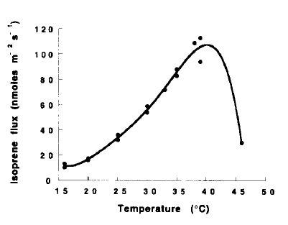

Figure 2. Isoprene emissions in functions of leaf temperature (closed circles) for white oak (Quercus alba) leaves. Fluxes are expressed per unit leaf area. From Lerdau et al. (1997).

Isoprene emissions are not only interacting with the short-term effects of temperature, but also they are influenced by the temperature changes over time period longer than one day. Petron et al. (2001) found that isoprene emissions depend on the average temperature experienced by the leaves in 15 days prior to measurement. The long-term effects of temperature change were also observed by other field studies; 18 hours (Geron et al., 2000) and 48 hours (Sharkey et al., 1999).

Isoprene emissions are also dependent upon light intensity. At a given temperature, isoprene emission rates are known to increase rapidly with increasing light intensity, saturating at light levels of 1000 to 1500 μmol m⁻² s⁻¹ (Figure 3a; Fehsenfeld et al., 1992; Lerdau et al., 1997). Due to the lack of appropriate (isoprene emissions measured at the light intensity between 1000 and 1500 μmoles m⁻² s⁻¹) measurement, same measurement, however, can be interpolated differently (constantly increasing with increasing light intensity) using different best fit method (Figure 3b; Feuntes et al., 2000).
a)
b)

Figure 3. Isoprene emissions from white oak (Quercus alba) leaves in function of PAR, photosynthetically active radiation (closed circles), from a) Lerdau et al. (1997) and b) Fuentes et al. (2000). The best fit curves for isoprene emission are shown in solid lines.

For tropical deciduous trees, isoprene emission does not saturate at certain point but instead continues to increase linearly as light intensity increases (Figure 4; Lerdau et al., 1997; Lerdau and Keller, 1997). Isoprene emission from kudzu has also been shown to respond to light intensities up to 3000 μmol m⁻² s⁻¹ (Sharkey and Loreto, 1993). The light effects over a few days can also influence isoprene emissions as found for temperature (Sharkey et al., 1999).

Figure 4. Isoprene emissions from tropical deciduous forest (Eugenia xerophytica) in function of PAR, photosynthetically active radiation (closed circles). From Lerdau et al. (1997).

Isoprene emission rates are remarkably different among shaded and sunlit leaves (Table 1; Sharkey et al., 1991), which can be explained both by the difference in temperatures and light intensity on the shaded and sunlit leaves. In forests, sunlit leaves are exposed to higher radiation and leaf temperature than shaded leaves located inside or at the bottom of the canopy; temperatures on the sunlit leaves are 4-5 ºC higher than that for shaded leaves (Lerdau and Keller, 1997). Also, isoprene emissions are low under dark conditions at all temperatures (Monson and Fall, 1989; Sharkey et al., 1991). Cloud cover similarly acts as total PAR, which can impact isoprene emission rates by influencing leaf temperature.

Table 1. Isoprene emissions (nmol m⁻² s⁻¹) from leaves of oak and aspen exposed to sun or shade. Leaf temperature was 25ºC and sun levels of 400 μmol m⁻² s⁻¹. From Sharkey et al. (1991).

 | Oak (n=5) | Aspen (n=3)
Sun | 30.6 ± 6.0 | 12.1 ± 1.7
Shade | 7.6 ± 2.9 | 7.4 ± 1.5

Seasonal temperature variation
Petron et al. (2001) showed that seasonal temperature variations influence isoprene emissions capacity in mature oak leaves. Temperature of 20-30°C affects emission capacities by a factor of 4. Monson et al. (1994) have also shown the developmental pattern of seasonal isoprene emission for aspen leaves by controlling environmental variable, such as temperature or light intensity by normalizing the isoprene emissions to 25ºC using the algorithm of Guenther et al. (1991) and filtering the measurements with PAR greater than 1000 μmol m⁻² s⁻¹ (Figure 5). Generally, isoprene emissions increase through the spring, peaking in mid-summer (early August), and then declining until leaf drop in the fall.
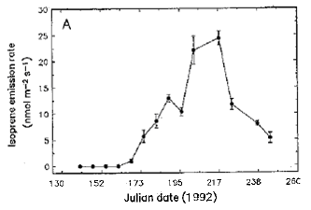

Figure 5. Seasonal pattern of isoprene emission for aspen leaves during the year 1992. All rates have been normalized to 25ºC, and only rates measured with PAR above 1000 μmol m⁻² s⁻¹ were shown. From Monson et al. (1994).

The springtime onset of isoprene emissions can be explained by cumulative temperature (or heating degree days); low isoprene emissions during the late-summer to early autumn can be explained by the low leaf nitrogen concentration which influences on the concentration of enzymes available for the isoprene synthesis (Figure 6a; Monson et al., 1994; Petron et al., 2001). However, seasonal variability of isoprene emissions can also be explained with the leaf developmental state; both young and senescent leaves emit low isoprene, whereas the highest emissions are measured for fully developed mature leaves during the main growing season (Figure 6b; Kuhn et al., 2004; Kuzma and Fall, 1993; Lerdau et al., 1997; Monson et al., 1994).

a)
b)
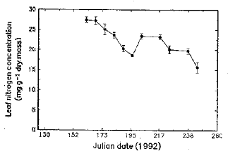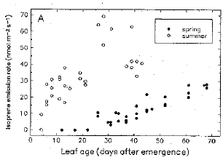

Figure 6. a) Seasonal pattern of leaf nitrogen concentration for aspen leaves during the year 1992. All rates have been normalized to 25ºC, and only rates measured with PAR above 1000 μmol m⁻² s⁻¹ were shown. b) The relationship between isoprene emission and leaf age that emerged during the spring (late February 1993; closed circles) or during the summer (late June 1993; open circles). From Monson et al. (1994).

Relative Humidity
Guenther et al. (1991) showed slight humidity dependence of isoprene emissions; 2.3 % increase in emission per 10 % increase in relative humidity (Figure 7). A similar phenomenon has been observed with isoprene emission rates from aspen leaves (Monson and Fall, 1989).
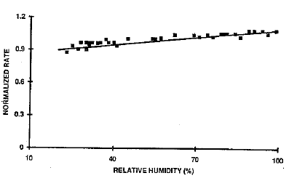

Figure 7. Normalized isoprene emissions from eucalyptus leaves (closed squares) in a function of relative humidity. Emission rates are normalized by the observed isoprene emission at a relative humidity of 40%. From Guenther et al. (1991).
By contrast, several researchers measured ambient concentration data from the Amazon basin, who found that dry season isoprene concentrations are higher than those in the wet season under similar conditions of temperature (Figure 8; Kesselmeier et al., 2002; Kuhn et al., 2004). This has been supported by canopy level isoprene emission rates from central Africa (Serca et al., 2001). Also, Sharkey and Loreto (1993) have shown, measuring isoprene emissions from kudzu (Pueraria lobata (Willd) Ohwi.) leaves, that water stress will lead to a slight increase, which can be explained by low stomatal conductance during the dry season which results in higher leaf temperature. Under severe stress, however, the rate of isoprene emission fell. When the isoprene production (obtained by subtracting isoprene absorbed by surrounding environment from isoprene emitted by trees) is considered, recent study of Pegoraro et al. (2005) showed that drought or water stressed condition not only increases isoprene emissions as result of partial stomatal closure, but also dramatically increases isoprene production as a result of reduced soil uptake of isoprene.
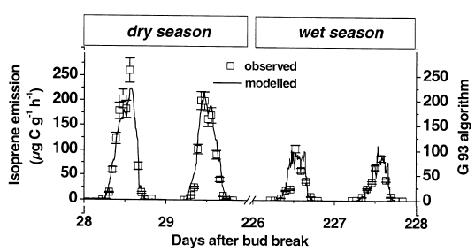

Figure 8. Observed isoprene emissions (μgC g⁻¹ h⁻¹) from drought-deciduous tree leaves (Hymenaea courbaril) measured in the dry season and the following wet season. Isoprene emission rates are simulated by an isoprene algorithm (Guenther et al., 1993). From Kuhn et al. (2002).
CO₂ Partial Pressure
The response of isoprene emission to CO₂ partial pressure varies by different tree species. Monson and Fall (1989) examined the isoprene emissions from aspen leaves, which showed a significantly reduced isoprene emissions at high CO₂ partial pressure. This has been supported by Sharkey et al. (1991). However, Sharkey et al. (1991) also showed the opposite response of isoprene emission from oak leaves to CO₂ partial pressure. Oak leaves from trees grown at high CO₂ partial pressure (65 Pa) had twice the rate of isoprene emission as leaves grown at normal CO₂ condition (40 Pa). Figure 9 shows the effect of CO₂ partial pressure on isoprene emission in both oak and aspen.
a)
b)
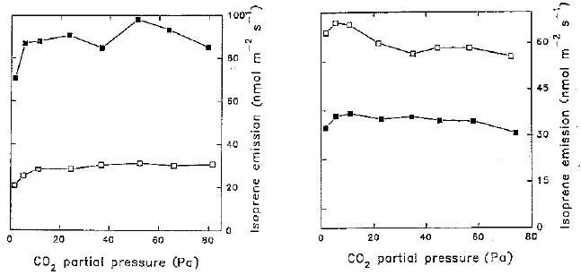

Figure 9. Isoprene emission (nmol m⁻² s⁻¹) of a) oak leaves and b) aspen leaves grown in ambient (open square) and high (closed square) CO₂ partial pressure (Pa). Leaf temperature was 30ºC and PAR was 900 μmol m⁻² s⁻¹. From Sharkey et al. (1991).

3. Conclusions
A comprehensive review of research on the sensitivity of biogenic emissions to climatic conditions; light, surface temperature, season, leaf development, relative humidity, CO₂ concentration, and other stresses is presented.
The results of this study show that both the temperature and solar radiation have a significant effect on the emissions from vegetation. It was noted that as the temperature increased until 40~44ºC, the isoprene emission rates increased. Due to the adverse effect of high temperatures on biosynthetic enzymes, isoprene emissions subsequently reduce at higher temperatures.
The effect of the solar radiation on the emissions from vegetation was also interesting. The widely used biogenic emission model, GloBEIS (Global Biosphere Emissions and Interactions System; Yarwood et al., 1999), estimates biogenic emissions based on the relationship shown in Figure 3a, which allows isoprene emissions to increase until the saturation point around 1000 μmol m⁻² s⁻¹. However, many studies have shown that isoprene emissions for various vegetation species continue to increase past 1000 μmol m⁻² s⁻¹. GloBEIS’ saturation point leads to the discrepancies between modeling results and observations.
Uncertainties in the effects of other climatic factors, e.g., relative humidity and CO₂ concentration, on isoprene emissions are also observed. These uncertainties in climatic factors arise due to the limited number of species and conditions for which emission measurements have been made.
In addition, these uncertainties in the isoprene emission rates can lead to greater uncertainties in the global / regional air quality prediction of other chemical species, most notably, tropospheric ozone.
Results of this review demonstrate that isoprene emissions are strongly linked to climate variables, e.g., temperature and light intensity, which have changed in the past and have great potential to change further in the future. Also, results have demonstrated that this link between isoprene emissions and climate variables should be considered with vegetation species. Since isoprene and other biogenic VOC play a large role in producing ground level ozone, a better understanding of the potential changes in biogenic emissions from natural global change, as well as human-induced change, is needed.
4. References
EPA, Health and environmental impacts of ground-level ozone. Available at http://www.epa.gov/air/urbanair/ozone/hlth.html
Fehsenfeld, F., Calvert, J., Fall, R., Goldan, P., Guenther, A. B., Hewitt, C. N., Lamb, B., Liu, S. T., M., Westberg, H. and Zimmerman, P. 1992. “Emissions of volatile organic compounds from vegetation and the implications for atmospheric chemistry.” Global Biogeochemical Cycles 6, 389-430.
Fuentes, J. D., Lerdau, M., Atkinson, R., Baldocchi, D., Bottenheim, J. W., Ciccioli, P., Lamb, B., Geron, C., Gu, L., Guenther, A., Sharkey, T. D. and Stockwell, W. 2000. “Biogenic hydrocarbons in the atmospheric boundary layer, A review.” Bulletin of the American Meteorological Society 81(7), 1537-1575.
Geron, C., Guenther, A., Sharkey, T., Arnts, R.R. 2000. “Temporal variability in basal isoprene emission factor.” Tree Physiology 20(12), 799-805.
Guenther, A., Archer, S., Greenberg, J., Harley, P., Helmig, D., Klinger, L., Vierling, L., Wildermuth, M., Zimmerman, P. and Zitzer, S. 1999. “Biogenic hydrocarbon emissions and landcover/climate change in a subtropical savanna.” Physics and Chemistry of the Earth Part B 24(6), 659-667.
Guenther, A., Geron, C., Pierce, T., Lamb, B., Harley, P. and Fall, R. 2000. “Natural emissions of non-methane volatile organic compounds, carbon monoxide, and oxides of nitrogen from North America.” Atmospheric Environment 34, 2205-2230.
Guenther, A., Hewitt, C.N., Erickson, D., Fall, R., Geron, C., Graedel, T., Harley, P., Klinger, L., Lerdau, M., McKay, W.A., Pierce, T., Scholes, B., Steinbrecher, R., Tallamraju, R., Taylor, J., Zimmerman, P. 1995. “A global model of natural volatile organic compound emissions.” Journal of Geophysical Research 100(D5), 8873-8892.
Guenther, A. B., Monson, R. K. and Fall, R. 1991. “Isoprene and monoterpene emission rate variability, Observations with Eucalyptus and emission rate algorithm development.” Journal of Geophysical Research 96(D6), 10799-10808.
Guenther, A. B., Zimmerman, P. R., Harley, P. C., Monson, R. K. and Fall, R. 1993. “Isoprene and monoterpene emission rate variability, Model evaluations and sensitivity analyses.” Journal of Geophysical Research 98(D7), 12609-12617.
Kesselmeier, J., Kuhn, U., Rottenberger, S., Biesenthal, T., Wolf, A., Schebeske, G., Andreae, M. O., Ciccioli, P., Brancaleoni, E., Frattoni, M., Oliva, S. T., Botelho, M. L., Silva, C. M. A. and Tavares, T. M. 2002a. “Concentrations and species composition of atmospheric volatile organic compounds (VOCs) as observed during the wet and dry season in Rondonia (Amazonia).” Journal of Geophysical Research 107(D20), 8053.
Kuhn, U., Rottenberger, S., Biesenthal, T., Wolf, A., Schebeske, G., Ciccioli, P., Kesselmeier, J. 2004. “Strong correlation between isoprene emission and gross photosynthetic capacity during leaf phenology of the tropical tree species Hymenaea courbaril with fundamental changes in volatile organic compounds emission composition during early leaf development.” Plant, Cell and Environment 27, 1469-1485.
Kuzma, J., Fall, R. 1993. “Leaf isoprene emission rate is dependent on leaf development and the level of isoprene synthase.” Plant Physiology 101, 435-440.
Lerdau, M., Guenther, A. and Monson, R. 1997. “Plant production and emission of volatile organic compounds.” Bioscience 47(6), 373-383.
Lerdau, M., Keller, M. 1997. “Controls on isoprene emission from trees in a subtropical dry forest.” Plant, Cell and Environment 20, 569-578.
Monson, R. K. and Fall, R. 1989. “Isoprene emission from aspen leaves - influence of environmental and relation to photosynthesis and photorespiration.” Plant Physiology 90(1), 267-274.
Monson, R. K., Harley, P. C., Litvak, M. E., Wildermuth, M., Guenther, A. B., Zimmerman, P. R. and Fall, R. 1994. “Environmental and developmental controls over the seasonal pattern of isoprene emission from aspen leaves.” Oecologia 99, 260-270.
National Research Council, 1991. “Rethinking the ozone problem in urban and regional air pollution.” National Academy Press, Washington, DC, 500pp.
Pegoraro, E., Abrell, L., van Haren, J., Barron-Gafford, G., Grieve, K.A., Malhi, Y., Murthy, R., Lin, G. 2005. “The effect of elevated atmospheric CO₂ and drought on sources and sinks of isoprene in a temperate and tropical rainforest mesocosm.” Global Change Biology 11, 1234-1246.
Petron, G., Harley, P., Greenberg, J. and Guenther, A. 2001. “Seasonal temperature variations influence isoprene emission.” Geophysical Research Letters 28(9), 1707-1710.
Serca, D., Guenther, A., Klinger, L., Vierling, L., Harley, P., Druilhet, A., Greenberg, J., Baker, B., Baugh, W., Bouka-Biona, C. and Loemba-Ndembi, J. 2001. “EXPRESSO flux measurements at upland and lowland Congo tropical forest site.” Tellus 53B, 220-234.
Sharkey, T.D., Loreto, F. 1993. “Water stress, temperature, and light effects on the capacity for isoprene emission and photosynthesis of kudzu leaves.” Oecologia 95, 328-333.
Sharkey, T. D., Loreto, F. and Delwiche, C. F. 1991. “High carbon dioxide and sun/shade effects on isoprene emission from oak and aspen tree leaves.” Plant, and Cell and Environment 14, 333-338.
Sharkey, T.D., Singsaas, E.L., Lerdau, M.T., Geron, C.D. 1999. “Weather effects on isoprene emission capacity and applications in emissions algorithms.” Ecological Applications 9(4), 1132-1137.
Tingey, D. T., Manning, M., Grothaus, L. C. and Burns, W. F. 1979. “Influence of light and temperature on isoprene emissions from live oak.” Physiologia Plantarum 47, 112-118.
Yarwood, G., Wilson, G., Emery, C., Guenther, A. “Development of the GloBEIS – A State of the Science Biogenics Emissions Modeling System.” Final Report to the Texas Natural Resource Conservation Commission, 12100 Park 35 Circle, Austin, Texas 78753, 1999.

